

Business System Design

For

Space Range and Display –

Sales Aggregation

Version: 0.6.1

Contents
1. Introduction 4
1.1 Scope 4
1.2 Assumptions 5
2. Overview 5
3. System Description 7
3.1 System Process Model 7
3.1.1 Receiving requests from CRDB 7
3.1.2 Sales Data extracted from ORMS 8
3.1.3 Sales Data Response 8
3.1.4 JDA Data Feed 11
3.1.5 House Keeping Activities 11
3.1.6 File Layout 12
3.2 System Data Model 13
3.3 Business Logic 14
3.3.1 For RPAS 14
3.3.2 For IKB 15
4. Interfaces 16
4.1 Request from CRDB: 16
4.2 Reference Relationship data from IKB: 17
4.3 Data from ORMS: 17
4.4 Response to RPAS: 18
4.5 Response to JDA: 19
4.5.1 IKB Response File - Products 19
4.5.2 IKB Response File – Products / Planogram 19
4.5.3 IKB Response File - Planogram 19
4.5.4 IKB Response File – Planogram / Stores 20
5. Security and Control Requirements 20

Document Control

Project: | Space Range and Display – Sales Aggregation
Document Title: | Business System Design for Sales Aggregation
Document Location:
Distribution: | Project Library  Mary Welch  Jon Braggs  Hilary Waterhouse  Kavita Suri | Eva Hotmarova  Jim Jeffrey  Andrew Barker  Samantha Baptiste

Change Record

Date | Author | Change Description |  | Version
22/03/2007 | Sudha Vaidyanathan | Initial Draft |  | 0.1
02/04/2007 | Sudha Vaidyanathan | Updated the document with the requirement change for JDA | 0.2
03/04/2007 | Sudha Vaidyanathan | Updated the document with the comments from Jim Jeffery and Andrew Barker | 0.3
04/04/2007 | Sudha Vaidyanathan | Document for sign off | 0.4
18/04/2007 | Sudha Vaidyanathan | Document for sign off with updated data model diagram and file name conventions | 0.5
17/05/2007 | Sudha Vaidyanathan | Incorporated the new change request for RPAS output | 0.6
25/05/2007 | Sudha Vaidyanathan | Change request for handling the Sub class code format change coming from CRDB | 0.6.1

Introduction

The following document will describe the Business Systems design required to meet the requirements as documented in the Business Requirements Document authored by Sudha Vaidyanathan.

It must be noted that the systems design within this document will relate only to requirements that are to be delivered within Priority 3 delivery for Space Range and Display. The completion and sign off of this document will pave the way for the Technical Design document to commence.

Scope

In Scope

The following table details the requirements from the Business requirements document that will be met by the development of Sales Aggregation – Phase 3

Requirement Reference | Requirement description | MoSCoW
001 | The Sales Aggregation Engine must provide an interface to enable Aggregated Sales History Data to be requested for a set of provided Item Numbers over a provided aggregation period and for a provided set of Stores associated with a Range Event | M
002 | The Sales Aggregation Engine must create a response data set of sales performance data | M
003 | The Sales Aggregation Engine must generate rolling 52 weeks historical sales and one week of actual sales data for IKB. | M
004 | The source un-aggregated sales data must be populated into the sales history database of the sales aggregation engine on daily basis | M
005 | The Sales Aggregation Engine must perform daily house keeping activities on Sales History database. | M

Out of Scope

The following table details the requirements that are out of scope of Sales Aggregation.

Requirement Reference | Requirement description | MoSCoW
001 | The Sales data request from CRDB is handled using interfaces in existing UK model with minimum changes. | M
002 | The Sales data response into RPAS and IKB is handled using interfaces in existing UK model with minimum changes. | M
003 | The Sales data request from IKB is handled using replenishment interface.
004 | The sales data must be extracted from ORMS database on a daily basis. | M

Change Request

The following table details the change in requirements that are in scope of Sales Aggregation.

Requirement Reference | Requirement description | MoSCoW
001 | The Sub Class Code coming from CRDB is modified. The handling of request which comes from CRDB must be modified to handle the changed Sub class code. | M
002 | The Sales data response into RPAS must be modified to include three more fields. | M

Assumptions
The Replenishment interface sends data in the form of flat files to Sales Aggregation Engine on a daily basis.

Overview

Draft Architecture – High level description of what will be required to support Sales Aggregation
(Expectation is that this diagram will be replaced by SA solution). This will be explained in detail in the following sections.

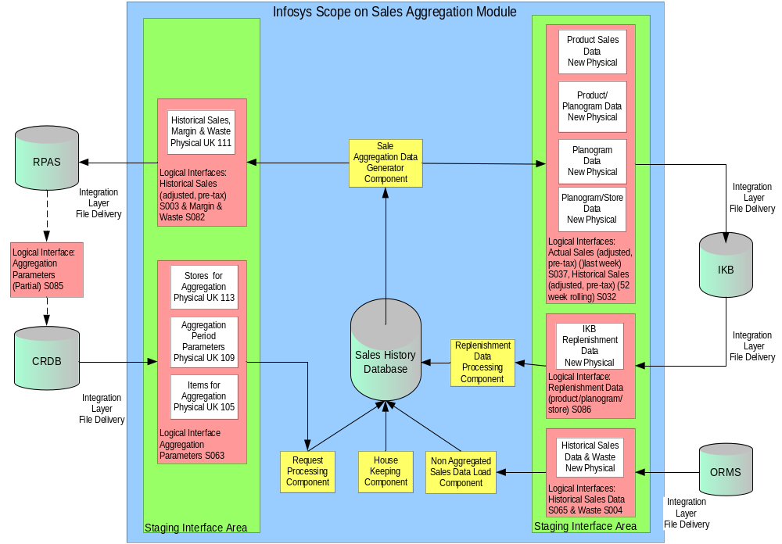

System Description

System Process Model

Receiving requests from CRDB

The sales aggregation system receives request from CRDB via integration layer. The Interface S063 will be used to generate these requests. The interface S063 categorise these requests into merchandising items to be aggregated, Aggregation Period and Stores for Aggregation. The CRDB will request sales data daily.

The integration layer provides these three requests in the form of flat files. These flat files will be picked by the Sales Aggregation request loader component and each request will be populated into a temporary table.

The response data generated for the request will be delivered to RPAS by the Integration Layer. The Integration Layer will deliver this data daily once created by the Sales Aggregation Processor component

The Request from CRDB consists of three physical files. The following table describes the field details of each of the flat files. In a day, there would be three flat files available for Sales Aggregation to process the requests from CRDB.

Each of the three physical files will consists of a header, a series of body records and footer. Every row in each of the files will start with a “record type” column indicating whether the row is a header, body or footer record.

The header, body and footer information are discussed in the File Layout section.

File Type | Column | Description
Display Hierarchy  (Items for Aggregation) | ItemNo | Unique Item number
Display Hierarchy  (Items for Aggregation) | Sub class Code 1 | Sub class 1 to which the item belongs to.
Display Hierarchy  (Items for Aggregation) | Range Event ID | Range Event to which the item belongs to.
Display Hierarchy  (Items for Aggregation) | ItemNo In Range Event | Item number that belongs to the range.
Display Hierarchy  (Items for Aggregation) | Sub Class Code 2 | Sub class 2 to which the item belongs to.
Display Hierarchy  (Items for Aggregation) | Sub Class Description | Description of the Sub class the item belongs to.
Aggregation Period | Range Event ID | Range Event to which the aggregation period belongs to.
Aggregation Period | Display Group Code | Display group code for the aggregation period.
Aggregation Period | Live Indicator | Event state indicator, Set = 1 if event is live, otherwise set = zero.  A live event is defined as the latest authorised event for a display group with a date <= current business date
Aggregation Period | Event Year/Week | Year and week of the occurrence of event
Aggregation Period | Fixed/Rolling Flag | Flag to indicate the period as fixed or rolling. It is ‘F’ or ‘R’.
Aggregation Period | Number of Rolling Weeks | Count of rolling weeks
Aggregation Period | Fixed Start Year/Week | Start year/week for fixed period
Aggregation Period | Fixed End Year/Week | End year/week for fixed period
Stores for Aggregation | Range Event ID | Range Event to which the aggregation period belongs to.
Stores for Aggregation | Display Group Code | Display group code for the aggregation period.
Stores for Aggregation | Store Range Cluster ID | Cluster ID for that store range
Stores for Aggregation | Space Break | It is the indication of space allocated for a merchandising group in a store.  The space break generally falls under A-K (11 count). A being the least space allocation and K being the most space allocation
Stores for Aggregation | Store Number | Unique store number

The following process flow will highlight the requests into Sales Aggregation

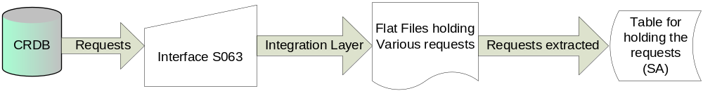

Sales Data extracted from ORMS

This is the source of Sales Data for the System. The daily sales data is extracted from the ORMS database into a flat file by the integration layer. The Integration layer sends the flat file to the Sales Aggregation.

These extracted sales data will be available for the Sales Aggregation engine in the form of flat files for processing various requests.

The following process flow will highlight the sales data extraction into Sales Aggregation.

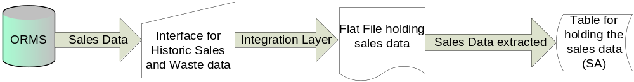

Sales Data Response

Sales Aggregation generates a single physical response file containing Sales History, Margin and Waste data. The format of this file will be as defined by the existing UK SRM Interface specification number 111. This single physical interface corresponds to the two SRD Logical Data Flows S003 & S082.

The header, body and footer information are discussed in the File Layout section.

The Response file for sales data will be of the format as given below:

File Type | Column | Description
Aggregated Performance Data | ItemNo | Unique Item number
Aggregated Performance Data | Range Event ID | Range Event to which the item belongs to.
Aggregated Performance Data | Store Cluster ID | Cluster ID for that store
Aggregated Performance Data | Range Class | It is the indication of space allocated for a merchandising group in a store.  The space break generally falls under A-Z (11 count). A being the least space allocation and K being the most space allocation
Aggregated Performance Data | Average Weekly Sales Value (inc.VAT) This Year | Average of the total sale of the item including VAT for this year
Aggregated Performance Data | Average Weekly Sales Value (inc.VAT) Last Year | Average of the total sale of the item including VAT for last year
Aggregated Performance Data | Average Sales Per Week (ex. VAT) | Average of the total sale of the item excluding VAT for a particular week
Aggregated Performance Data | Average Singles Per Week | Average of the total item sold as singles for a particular week
Aggregated Performance Data | Average Weight Per Week | Average of the total weight of the item sold for a particular week
Aggregated Performance Data | Average No Of Stores for Sales | Average of the total number of stores which have sold that item for a particular week
Aggregated Performance Data | Average Waste Value Per Week | Average of the total waste sale of the item for a particular week
Aggregated Performance Data | Average No Of Stores for Waste | Average of the total number of stores which have wasted that item for a particular week
Aggregated Performance Data | Average Margin Value Per Week | Average of the total retail price minus the total cost for the item for that particular week
Aggregated Performance Data | Average No Of Stores for Margin | Average of the total number of stores considered for the margin for the particular week
Aggregated Performance Data | Launch / Promo Flag | This will always be blank

These Sales performance measures will be accurately available to Ranging systems for setting up of ranges.

- The Sales history for implemented plans will be based on the history period of rolling 52 weeks and fixed aggregation period.
- The Sales history will be customized exactly for each Range i.e. sales will be aggregated only from stores in the store cluster and with the range class that the Range relates to. The store cluster and range class details are sent by CRDB as part of stores for aggregation interface file.
- The system will generate performance data based on waste, margin and other key elements
- Weeks with zero sales will be excluded from the calculation. Similarly, calculations of other performance measures which register zero in any week will exclude that week.
- Each performance measure will be calculated independently of the others i.e. a week with zero sales will not influence the calculation of average margin.
- No provision is available to produce an individual sales figure for any multi-located product, as sales/shelf is not captured.

Example
There are 4 stores with the same Range Class (space break) in a store range group which have the following sales for a product over a 4-week period.
Store | Week 1 | Week 2 | Week 3 | Week 4 | Week 5 | Week 6 | Week 7 | Total
Store A | 20 | 10 | 50 | 0 | 20 | 20 | 30 | 150
Store B | 0 | 0 | 0 | 0 | 30 | 20 | 20 | 70
Store C | 70 | 300 | 20 | 0 | 0 | 0 | 0 | 120
Store D | 50 | 40 | 80 | 0 | 10 | 40 | 40 | 260
Store E | 30 | 20 | 20 | 0 | 20 | 10 | 20 | 120
 |  |  |  |  |  |  |  | 720
Total sales = 720
Total datapoints = 24
Total weeks with sales = 6
Average weekly sales per store per week = 720 / 24 = 30
Average number of stores per week = 24 / 6 = 4
Average weekly sales for the store range group / space break = 30 * 4 = 120

For calculating the average sales value, we follow the below logic:
1. For TRAN_CODE = 1 (inclusive of VAT), Total retail will indicate the total selling price inclusive of VAT of the product in that store in that day. Since the VAT_RATE is also known, subtract the vat rate from the total retail to get the total retail excluding of VAT.
E.g. Total Retail (Ex VAT) = Total Selling Price / ((VAT_RATE / 100) + 1)

And the example: VAT_RATE = 17.5% & Total Retail = 150 then
Total Retail (Ex VAT) = 150 / ((17.5/100) + 1) = 127.6595
This new total retail value will be used for calculating the average weekly sales value exclusive of vat for this week for this year and last year.
2. For TRAN_CODE = 2 (exclusive of VAT), then average sales inclusive of VAT will be same as exclusive of VAT.
3. TRAN_CODE = 22 corresponds to sales for waste.
4. Average sales inclusive of VAT for both this year and last year will be just 1 week data calculation. For exclusive of VAT, then it is for entire aggregation period (rolling/fixed).
e.g. for inclusive of VAT this year, you calculate the average sales for the present week, say you are handling sales for 2007/11. For last year, you will be calculating for 2006/11 (52 weeks difference).

The following process flow will highlight the response into RPAS from Sales Aggregation.

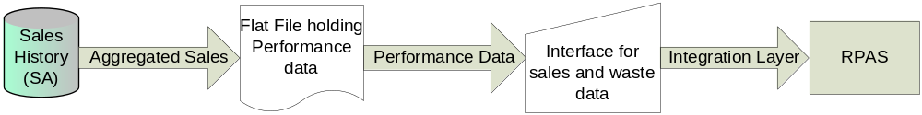

JDA Data Feed

For IKB the rolling 52 weeks historic sales data and weekly actual sales data should be send once a week. The replenishment interface sends the Product/Planogram/Store relationship data from IKB in the form of flat file on a nightly basis.

The Historic Sales and Actual Sales units and values will be extracted from the Sales Aggregation Engine for each of the 4 levels of aggregation required for all LIVE Planogram. The interface S032 will be used to send these data’s to IKB. Sales Aggregation generates 4 flat files comprising of actual and historic sales data for four aggregation level.

- Historic Sales – the average weekly sales volume (units) and value (£), within a rolling 52 week window
- Actual Sales – the average weekly sales volume (units) and value (£) for the previous week

The JDA sales data will be of the format as given below:

- IKB needs a weekly feed of both rolling 52 weeks historic sales and actual sales for live plans from the sales aggregation engine.
- Each performance measure will be calculated independently of the others i.e. a week with zero sales will not influence the calculation of average margin.
- Weeks with zero sales will be excluded from the calculation. Similarly, calculations of other performance measure which register zero in any week will exclude that week.
- No provision is available to produce an individual sales figure for any multi-located product, as sales/shelf is not captured.
- It is thought that the Planogram level data elements can be derived from the Planogram/Store level values within the Sales Aggregation Engine

The following process flow will highlight the response into JDA from Sales Aggregation.

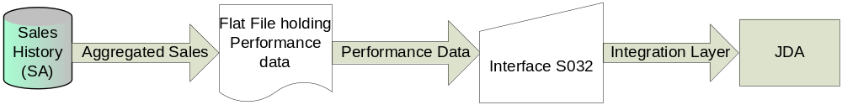

House Keeping Activities

The Sales Aggregation must perform periodic house keeping activities in Sales History database. The System must clean the Sales History database on a weekly basis. The house keeping activity is an automatic activity which would be carried out for cleaning the database for weeks of sales history beyond 2 years.

The house keeping activity thus ensures removal of redundant and unwanted data and in turn improves the performance of the sales history database.

File Layout

Headers
RTYYYYMMDDhhmmssYYYYMMDD
RT = standard header record indicator value, always 00
YYYYMMDDhhmmss = date/time when file is created
YYYYMMDD = date for which the data is processed/extracted.

Data
RRxxxxxxxxxxxx
RR = Data record, always 01
xxxxxxxxxxxx = Details in integration specification

Footers
RRCCCCCCCCCC
RR = Footer record, always 99
CCCCCCCCCC = Record count, 9999999999 (Integer 10), this will count data records only, excluding header and footer. The number will contain leading zeros.

Naming
To ensure that files are not over written they need to be unique, to achieve this, the following suffix to the file name is required:
BusinessDate_SourceSystem_SystemDescription_SystemCreationDate_SystemC reationTime.extension
Eg: 20070408_CRDB_ProductParams_20070408_223325.txt

Business Date = yyyymmdd format
Source System = CRDB, IKB or ORMS
System Description = brief text description to identify the content of the file
System creation date = yyyymmdd format
System creation time = hhmmss format

Sample file names for all the interfaces are listed below

CRDB Input files:
20070408_CRDB_ProductParams_20070408_223325.txt
20070408_CRDB_PeriodParams_20070408_221236.txt
20070408_CRDB_StoreParams_20070408_225510.txt

ORMS Input file:
20070408_ORMS_DataExtract_20070408_224650.txt

IKB Input file:
20070408_IKB_ReplenishmentDataExtract_20070408_231010.txt

RPAS Response file:
20070408_RPAS_AggregatedPerformanceData_20070409_031515.txt

IKB Response files:
20070408_IKB_SalesDataForProduct_20070409_031515.txt
20070408_IKB_SalesDataForProductPerPlanogram_20070409_031515.txt
20070408_IKB_SalesDataForPlanogram_20070409_031515.txt
20070408_IKB_SalesDataForPlanogramPerStore_20070409_031515.txt

During normal operation the business date and creation date should be the same, unless the file is created after midnight. However during testing, these dates are likely to be different.

System Data Model
The detailed database design will be completed by Infosys as part of the technical design process. The information below is to be used as a guide to the information that the database will be required to support as a minimum.

The following structure details the tables, columns and key constraints associated with Sales Aggregation Engine. The logic of forming requests and responses are captured in TSD.

Request from CRDB is processed to form response to RPAS

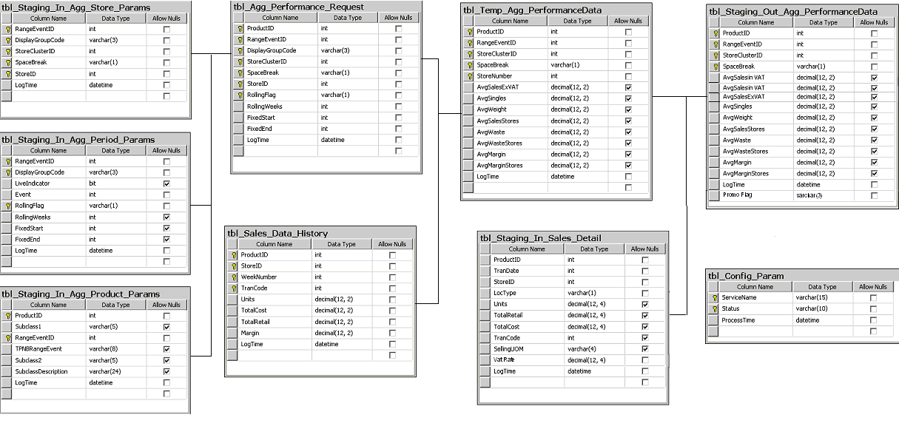

Request from IKB is processed to form response back to IKB

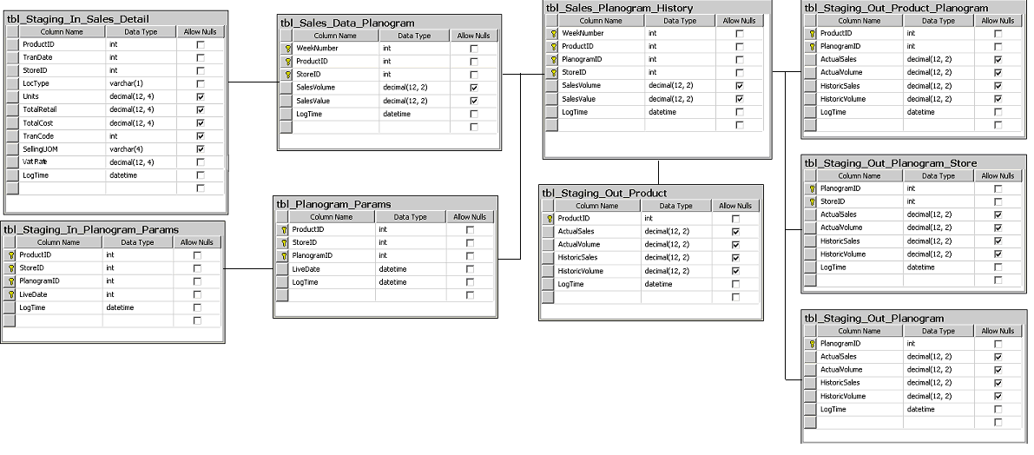

Business Logic

The business logic comprises of aggregation of sales data from sales history database and send out these performance sales data to RPAS and IKB.

For RPAS

Average Weekly Sales Value (inc.VAT) This Year | Sum of sales units inc of VAT of the product for the week / Count of the no. of stores selling the Product for this year
Average Weekly Sales Value (inc.VAT) Last Year | Sum of sales units inc of VAT of the product for the week / Count of the no. of stores selling the Product for last year
Average Sales Per Week (ex. VAT) | Sum of sales units of the product exc VAT for the week / Count of the no. of stores selling the Product for that aggregation period
Average Singles Per Week | Sum of sale of single units of the product for the week / Count of the no. of stores selling the Product for that aggregation period
Average Weight Per Week | Sum of sales of Weight of the product for the week / Count of the no. of stores selling the Product for that aggregation period
Average No Of Stores for Sales | Count of the no. of stores selling the Product in the week / Aggregation period
Average Waste Value Per Week | Sum of waste units of the product for the week / Count of the no. of stores where the Product has gone waste in the week for that aggregation period
Average No Of Stores for Waste | Count of the no. of stores wasted the Product in the week / Number of days of the week of product gone waste for that aggregation period
Average Margin Value Per Week | Total selling price – Total cost price of the product for that aggregation period
Average No Of Stores for Margin | Count of the no. of stores having margin value for the Product in the week / Aggregation period

For IKB

The following aggregation logic is based on the assumption that the Sales Aggregation Engine will hold raw sales data at product/Planogram/store/week level. Any records where sales values or units =0 should be ignored to ensure these averages are not skewed by unusual events (e.g. for some new products, supply chain issues may result in zero sales for a few weeks whilst the product is on live Planogram).

 | Product | Product/Planogram | Planogram | Planogram/Store
Actual Sales (units) | Sum of sales units of the product for the week / Count of the no. of stores selling the Product in the week | Sum of sales units of the product for the week across stores with that Planogram / Count of no. of stores with that Planogram in that week, where the Product has sales | Sum of sales units of all the products in the planogram for the week / Count of no. of stores with that Planogram in that week, where the Planogram has sales | Sum of sales units of all the products in the planogram at a particular store for the week
Actual Sales (£) | Sum of sales (£) of the product for the week / Count of the no. of stores selling the Product in the week | Sum of sales (£) of the product for the week across stores with that Planogram / Count of no. of stores with that Planogram in that week, where the Product has sales | Sum of sales (£) of all the products in the planogram for the week / Count of no. of stores with that Planogram in that week, where the Planogram has sales | Sum of sales (£) of all the products in the planogram at a particular store for the week
Historic sales (units) | Sum of sales units of the product over 52 weeks / Count of the unique no. of week/store combinations where the Product has sales | Sum of sales units of the product over 52 weeks across stores with that Planogram / Count of no. of store/week combinations where the Product within that Planogram has sales | Sum of sales units of all the products in the planogram across 52 weeks / Count of no. of store/week combinations with that Planogram, where the Planogram has sales | Sum of sales units of all the products in the planogram at a particular store over 52 weeks / Count of the number of weeks where the Planogram has sales in the store
Historic sales (£) | Sum of sales (£) of the product over 52 weeks / Count of the unique no. of week/store combinations where the Product has sales | Sum of sales (£) of the product over 52 weeks across stores with that Planogram / Count of no. of store/week combinations where the Product within that Planogram has sales | Sum of sales (£) of all the products in the planogram across 52 weeks / Count of no. of store/week combinations with that Planogram, where the Planogram has sales | Sum of sales (£) of all the products in the planogram at a particular store over 52 weeks / Count of the number of weeks where the Planogram has sales in the store

Interfaces

Sales Aggregation will require data from the Integration layer consisting of the following items:

Request from CRDB:

File Type | Column | Description | Positions
Display Hierarchy  (Items for Aggregation) | Record Type | It corresponds to each row in the file.  For File Body it’s value is 01; File Header it’s 00 and File Footer it’s 99 | 1-2
Display Hierarchy  (Items for Aggregation) | ItemNo | Unique Item number | 3-11
Display Hierarchy  (Items for Aggregation) | Sub class Code 1 | Sub class 1 to which the item belongs to. | 12-23
Display Hierarchy  (Items for Aggregation) | Range Event ID | Range Event to which the item belongs to. | 24-31
Display Hierarchy  (Items for Aggregation) | ItemNo In Range Event | Item number that belongs to the range. | 32-39
Display Hierarchy  (Items for Aggregation) | Sub Class Code 2 | Sub class 2 to which the item belongs to. | 40-51
Display Hierarchy  (Items for Aggregation) | Sub Class Description | Description of the Sub class the item belongs to. | 52-75
Aggregation Period | Record Type | It corresponds to each row in the file.  For File Body it’s value is 01; File Header it’s 00 and File Footer it’s 99 | 1-2
Aggregation Period | Range Event ID | Range Event to which the aggregation period belongs to. | 3-10
Aggregation Period | Display Group Code | Display group code for the aggregation period. | 11-13
Aggregation Period | Live Indicator | Event state indicator, Set = 1 if event is live, otherwise set = zero.  A live event is defined as the latest authorised event for a display group with a date <= current business date | 14
Aggregation Period | Event Year/Week | Year and week of the occurrence of event | 15-20
Aggregation Period | Fixed/Rolling Flag | Flag to indicate the period as fixed or rolling. It is ‘F’ or ‘R’. | 21
Aggregation Period | Number of Rolling Weeks | Count of rolling weeks | 22-24
Aggregation Period | Fixed Start Year/Week | Start year/week for fixed period | 25-30
Aggregation Period | Fixed End Year/Week | End year/week for fixed period | 31-36
Stores for Aggregation | Record Type | It corresponds to each row in the file.  For File Body it’s value is 01; File Header it’s 00 and File Footer it’s 99 | 1-2
Stores for Aggregation | Range Event ID | Range Event to which the aggregation period belongs to. | 3-10
Stores for Aggregation | Display Group Code | Display group code for the aggregation period. | 11-13
Stores for Aggregation | Store Range Cluster ID | Cluster ID for that store range | 14-18
Stores for Aggregation | Region Code | Region Code | 19
Stores for Aggregation | Space Break | It is the indication of space allocated for a merchandising group in a store.  The space break generally falls under A-K (11 count). A being the least space allocation and K being the most space allocation | 20
Stores for Aggregation | Store Number | Unique store number | 21-25

Reference Relationship data from IKB:
Live Date from the replenishment interface will be used to identify live relationships against which the sales data will be aggregated.

File Type | Column | Description | Positions
Replenishment Data Interface | Record Type | It corresponds to each row in the file.  For File Body it’s value is 01; File Header it’s 00 and File Footer it’s 99 | 1-2
Replenishment Data Interface | DateTime | Date and time | 3-12
Replenishment Data Interface | Store Number | Unique store number | 13-22
Replenishment Data Interface | Planogram ID | Planogram ID associated with the Product ID | 23-42
Replenishment Data Interface | Display group | Display group associated with the Product ID | 43-62
Replenishment Data Interface | Event ID | Event ID associated with the Product ID | 63-82
Replenishment Data Interface | Object live date (planogram or floorplan as appropriate) | Live date associated with the Planogram ID | 83-90
Replenishment Data Interface | Object end date (planogram or floorplan as appropriate) | End date associated with the Planogram ID | 91-98
Replenishment Data Interface | Product ID | Unique Product ID | 99-118
Replenishment Data Interface | Capacity | Info on Capacity | 119-123
Replenishment Data Interface | Number of facings wide | Info on Facings | 124-128
Replenishment Data Interface | Number of labels | Count of Labels | 129-131
Replenishment Data Interface | Promotional indicator (generated by this process) | Promotional Indicator | 132
Replenishment Data Interface | Shelf-ready packaging indicator | Packaging indicator | 133
Replenishment Data Interface | Multi-located indicator | Multi-located indicator | 134

Data from ORMS:

Integration layer will provide sales aggregation specific sales data ORMS database on a daily basis in the form of a flat file.
The flat file should provide the following field details required for Sales Aggregation:

File Type | Column | Description | Positions | Remarks
Sales Data from ORMS | RecordType | Constant – 01 for record row | 1-2 | ‘01’
Sales Data from ORMS | ItemNo | Unique Item number | 3-11 | varchar
Sales Data from ORMS | Tran Date | Transaction Date | 12-19 | In the format ‘yyyymmdd’
Sales Data from ORMS | Location | Store number | 20-24 | Numeric (prefix with zeroes)
Sales Data from ORMS | Loc Type | whether Store or warehouse | 25 | varchar
Sales Data from ORMS | Units | Quantity of sale of the item | 26-37 | Numeric (12,4) eg: 123.456 should be represented as 0000123.4560. If the value is negative say -123.456, then it should be displayed as -000123.4560
Sales Data from ORMS | Total Cost | Total cost price of the item | 38-49 | Numeric (12,4) eg: 123.456 should be represented as 0000123.4560. If the value is negative say -123.456, then it should be displayed as -000123.4560
Sales Data from ORMS | Total Retail | Total selling price of the item | 50-61 | Numeric (12,4) eg: 123.456 should be represented as 0000123.4560. If the value is negative say -123.456, then it should be displayed as -000123.4560
Sales Data from ORMS | Tran Code | Transaction Code | 62-63 | Numeric (prefix with zeroes) ie. Tran code 2 should be displayed as 02
Sales Data from ORMS | Selling UOM | Selling unit of measure | 64-65 | Varchar – either ‘EA’ or spaces
Sales Data from ORMS | VAT Rate | This field will contain the vat rate at the selling store. This field will only contain a value for records with a TRAN_CODE = 1 | 66-72 | Numeric (7,3) eg: 2.345 should be represented as 012.345.

Sales Aggregation will provide the following information to the integration layer:

Response to RPAS:

Response Type | Column | Description | Position Position
Aggregated Performance Data | Record Type | It corresponds to each row in the file.  For File Body it’s value is 01; File Header it’s 00 and File Footer it’s 99 | 1-2
Aggregated Performance Data | ItemNo | Unique Item number | 3-11
Aggregated Performance Data | Range Event ID | Range Event to which the item belongs to. | 12-19
Aggregated Performance Data | Store Cluster ID | Cluster ID for that store | 20-24
Aggregated Performance Data | Range Class | It is the indication of space allocated for a merchandising group in a store.  The space break generally falls under A-Z (11 count). A being the least space allocation and K being the most space allocation | 25
Aggregated Performance Data | Average Weekly Sales Value (inc.VAT) This Year | Average of the total sale of the item including VAT for this year | 26-37
Aggregated Performance Data | Average Weekly Sales Value (inc.VAT) Last Year | Average of the total sale of the item including VAT for last year | 38-49
Aggregated Performance Data | Average Sales Per Week (ex. VAT) | Average of the total sale of the item excluding VAT for a particular week | 50-61
Aggregated Performance Data | Average Singles Per Week | Average of the total item sold as singles for a particular week | 62-73
Aggregated Performance Data | Average Weight Per Week | Average of the total weight of the item sold for a particular week | 74-85
Aggregated Performance Data | Average No Of Stores for Sales | Average of the total number of stores which have sold that item for a particular week | 86-93
Aggregated Performance Data | Average Waste Value Per Week | Average of the total waste sale of the item for a particular week | 94-105
Aggregated Performance Data | Average No Of Stores for Waste | Average of the total number of stores which have wasted that item for a particular week | 106-113
Aggregated Performance Data | Average Margin Value Per Week | Average of the total retail price minus the total cost for the item for that particular week | 114-125
Aggregated Performance Data | Average No Of Stores for Margin | Average of the total number of stores considered for the margin for the particular week | 126-133
Aggregated Performance Data | Launch / Promo Flag | This will always be blank | 134-136

Response to JDA:

IKB Response File - Products

Aggregated Actual and Historic Sales Data | Record Type | 1-2
Aggregated Actual and Historic Sales Data | Product No | 3-11
Aggregated Actual and Historic Sales Data | Actual Sales Volume (value) | 12-23
Aggregated Actual and Historic Sales Data | Actual Sales Volume (Units) | 24-35
Aggregated Actual and Historic Sales Data | Historic Sales Volume (value) | 36-47
Aggregated Actual and Historic Sales Data | Historic Sales Volume (Units) | 48-59

IKB Response File – Products / Planogram

Aggregated Actual and Historic Sales Data | Record Type | 1-2
Aggregated Actual and Historic Sales Data | Product No | 3-11
Aggregated Actual and Historic Sales Data | Planogram ID | 12-17
Aggregated Actual and Historic Sales Data | Actual Sales Volume (value) | 18-29
Aggregated Actual and Historic Sales Data | Actual Sales Volume (Units) | 30-41
Aggregated Actual and Historic Sales Data | Historic Sales Volume (value) | 42-53
Aggregated Actual and Historic Sales Data | Historic Sales Volume (Units) | 54-65

IKB Response File - Planogram

Aggregated Actual and Historic Sales Data | Record Type | 1-2
Aggregated Actual and Historic Sales Data | Planogram ID | 3-8
Aggregated Actual and Historic Sales Data | Actual Sales Volume (value) | 9-20
Aggregated Actual and Historic Sales Data | Actual Sales Volume (Units) | 21-32
Aggregated Actual and Historic Sales Data | Historic Sales Volume (value) | 33-44
Aggregated Actual and Historic Sales Data | Historic Sales Volume (Units) | 45-56

IKB Response File – Planogram / Stores

Aggregated Actual and Historic Sales Data | Record Type | 1-2
Aggregated Actual and Historic Sales Data | Planogram ID | 3-8
Aggregated Actual and Historic Sales Data | Store ID | 9-13
Aggregated Actual and Historic Sales Data | Actual Sales Volume (value) | 14-25
Aggregated Actual and Historic Sales Data | Actual Sales Volume (Units) | 26-37
Aggregated Actual and Historic Sales Data | Historic Sales Volume (value) | 38-49
Aggregated Actual and Historic Sales Data | Historic Sales Volume (Units) | 50-61

Security and Control Requirements
The security of the system must adhere to Group Standards as defined by GT&A.

The system will have a central sales aggregation database to store sales history data.

